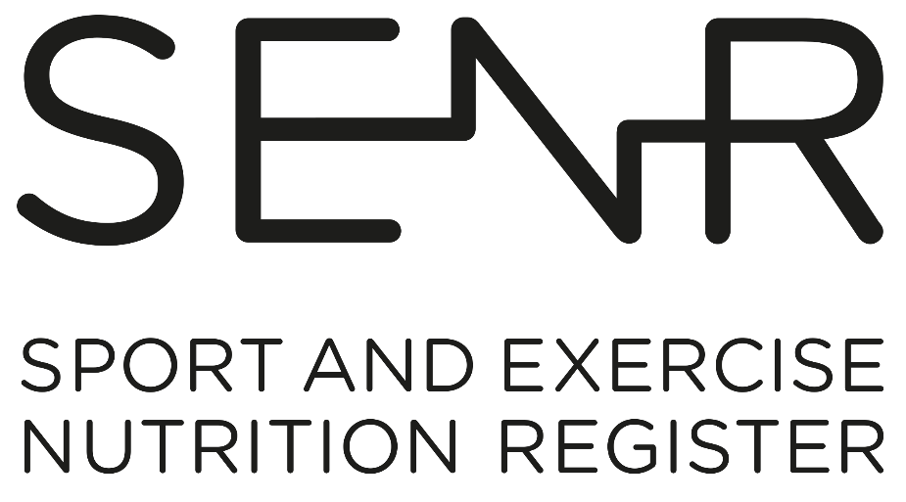

**Competency Framework for the Sport and Exercise Nutrition Register (SENR)**

***Graduate & Practitioner***

***October 2022***

***Published: October 2016***

**Competency Framework for the Sport and Exercise Nutrition Register (SENR)**

***Graduate & Practitioner***

**Published:**

**Review Date:**

**TBC**

Contents

Introduction 3

PART 1: Scientific Knowledge (Section A) 5

PART 2. Professional Application (Sections B - F) 10

References 19

# 

# Introduction

The key to optimal nutrition for physically active individuals, particularly the elite performer, is individualisation and personalised approaches. This encompasses assessment, education, and counselling to design, implement and evaluate nutrition strategies to enhance health and optimise performance.

Sport and exercise nutritionists enter the profession as a Graduate Registrant and develop competency through practice during their early post-registration years. They are encouraged to engage in continual professional development to advance their practice and deliver better outcomes for service users as they work towards achieving full Practitioner Registration status.

This document describes in detail the collection of competencies applicants will be expected to demonstrate in order to achieve a) Graduate Registration and b) Practitioner Registration.

All applicants (both for Graduate and Practitioner status) must meet the competency requirements in Section A, thus demonstrating robust and sound academic subject knowledge. This will be achieved through a combination of undergraduate and postgraduate study as outlined in the ‘SENR Guide to Registration’[1]. ***Meeting the requirements set out in Section A will ensure an applicant’s eligibility to join the SENR Graduate Register***.

Applicants applying to join the Practitioner Register must submit a portfolio of evidence to demonstrate competency in the professional application of sport and exercise nutrition. ***Meeting the requirements set out in Sections A-F will ensure an applicant’s eligibility to join the SENR Practitioner Register***. Section F will be assessed against the case study element of the portfolio.

An overview of the SENR Competency Framework is provided in Figure 1.

**Figure 1. SENR Competency Framework**

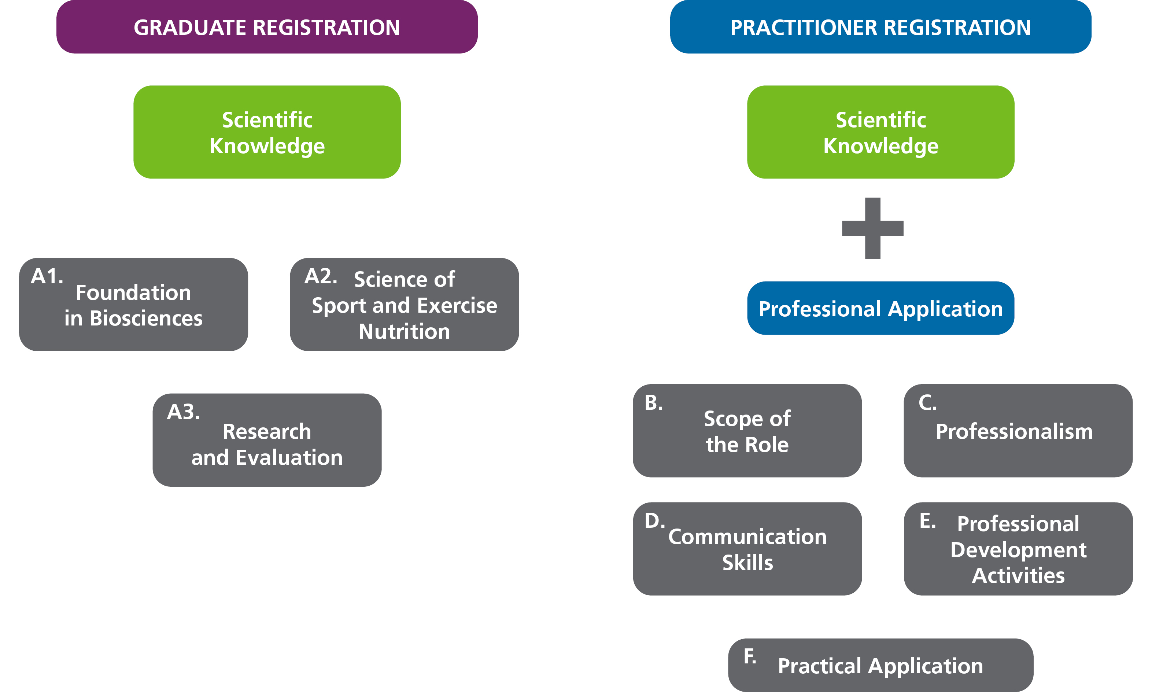

Within the Framework, competencies are categorised into two categories: Essential (E) and Desirable (D). Competencies within the Graduate Registration Framework are **ALL** essential. Competencies within the Practitioner Registration Framework are marked essential or desirable. With particular regard to the areas marked essential, unless otherwise stated, competency means sufficient knowledge, understanding and skill for application in safe, sound, effective and ethical practice.

Note: For some applicants a desirable competency, may be essential for the context in which you work, for example competency area C2 ‘understand the particular needs of special athlete populations (e.g., young and para-sport athletes) and tailor advice and guidance as appropriate’. If your work context includes these special athlete populations then you need to demonstrate competence in this area.

# PART 1: Scientific Knowledge (Section A)

All Registrants, both at Graduate and Practitioner, must demonstrate the competencies outlined in Section A.

The **Scientific Knowledge** base has three components:

1. Foundation in Biosciences.
2. Science of Sport and Exercise Nutrition
3. Research and Evaluation

**NB: Registrants must demonstrate comprehensive understanding of the knowledge and skills outlined in Section A. This will be through a combination of undergraduate and postgraduate academic training in dietetics, nutrition, and sports science. Please refer to the Guide to Registration for further information. Applicants are required to submit evidence of qualifications achieved when seeking Graduate Registration.**

***NB: If your postgraduate qualification is via a SENR Accredited programme you only need to submit evidence of your postgraduate award.***

|  |  |
| --- | --- |
| **Name of Applicant** |  |
| **Date of Submission** |  |

***SENR Competency Assessment Form (Office Use Only)***

|  |  |
| --- | --- |
| **Name of Assessor** |  |
| **Date of Assessment** |  |
| **Panel Review Date** |  |

**All competencies in Section A are deemed to be Essential and must be met by all applicants.**

|  |  |
| --- | --- |
| **No.** | **Scientific Knowledge** |
| **A1** | **Foundation in Biosciences** |
| **A1.1** | Know and understand the human body and its functions, especially digestion, absorption, excretion, respiration, fluid and electrolyte balance, the cardio-vascular system, neuro-endocrine system, musculoskeletal system, immunity, and thermoregulation. |
| **A1.2** | Know and understand mechanisms for the integration of metabolism at molecular, cellular, and whole-body levels. |
| **A2** | **Science of Sport and Exercise Nutrition** |
| **A2.1** | ***Basic Nutrition*** |
| **A2.1.1** | Know, understand, and have the ability to critically evaluate methods of measurement and evaluation including anthropometric, dietary, biochemical, physiological and functional methods of assessment. |
| **A2.1.2** | Know, understand, and have the ability to critically evaluate the theory and methods of investigating the dietary and nutrient patterns of the general population and subgroups of the population. This will include analysis of qualitative and quantitative dietary and nutritional data, utilising database systems as appropriate. |
| **A2.1.3** | Know, understand, and critically evaluate nutrition science and its role in promoting human health including the:   * role of macro and micronutrients and other metabolically active components of food (e.g., fibre); * metabolic effects of anti-nutrients (e.g., tannins), food additives, pharmacologically active agents (drugs); * nutrient-nutrient interactions; * potential of ‘nutraceuticals’ and functional foods; * the nutritional composition of foods. |
| **A2.1.4** | Know, understand, and have the ability to critically evaluate the scientific basis for the measurement and estimation of nutritional requirements, limitations and usefulness of dietary reference values and recommended dietary allowances for the general population and safe upper levels of individual nutrients including in the context of the special needs of vulnerable groups. |

|  |  |  |
| --- | --- | --- |
| **A2.1.5** | Know and understand the aetiology of nutritional or nutrition-related problems that are relevant to sport and exercise performance. | |
| **A2.1.6** | Know and understand how to take ethnicity or culture into account in formulating practical advice in terms of foods, meals, and menus. | |
| **A2.1.7** | Know and understand how to take dietary preferences into account in formulating practical advice in terms of foods, meals and menus (e.g., vegetarian and plant based eating). | |
| **A2.1.8** | Know and understand the principles of food preparation, handling, management, and safety. | |
| **A2.2** | ***Specialist Knowledge in Sport and Exercise Nutrition*** | |
| **A2.2.1** | Know and understand the nature of different sports to ensure an interdisciplinary approach to nutrition support to include:   * principles and components of fitness; * physiological and biochemical demands of participation in sport and exercise; * training practices, physical demands and rules of sports; * lifestyles of clients; * the nutritional implications of the physiological demands of training for and competing in sport and exercise. | |
| **A.2.2.2** | Know, understand, and critically evaluate the theoretical basis for the metabolic effects, efficacy, health, safety, and legal aspects of ergogenic aids of all kinds including pharmacologically active agents, sports foods, sports drinks, and supplements demonstrating an awareness of clean sport principles, current WADA prohibited list and practitioner responsibilities when operating in this area of practice. | |
| **A2.2.3** | Appreciate the ambitions, values, beliefs, motivations, and psychosocial concerns of clients. Know and understand contemporary models of behaviour change to underpin the development of effective interventions. | |
| **A2.3** | | ***Nutrition, Health, Exercise and Sport*** |
| **A2.3.1** | | Know and understand the effects of disease processes on:   * diet and nutrition; * exercise and sport performance. |
| **A2.3.2** | | Know and understand how to:   * elicit relevant information for the formulation of appropriate advice; * select, assess, and analyse information in order to formulate recommendations about nutrient requirements and status of client(s); * design advice that will optimise performance and give consideration to the health of the client(s); * demonstrate a food first approach to meeting nutritional needs using appropriate and targeted supplementation where necessary; * understand anti-doping regulations and how to advise clients regarding use of supplements and the necessity for risk mitigation protocols. |
| **A3** | | **Research and Evaluation** |
| **A3** | | Know, understand, and have the ability to critically evaluate a range of valid and reliable research methods appropriate to evidence-based practice in sport and exercise nutrition. Continually evaluating contemporary research to ensure own practice is evidence-based and up to date. |

# PART 2. Professional Application (Sections B - F)

**Practitioner** Registrants must demonstrate the competencies outlined in PART 2 (Sections B-F).

It is the **application** of the knowledge, skills and behaviours of Sport & Exercise Nutrition professionals that enables **Practitioner** registration with the SENR. The competencies outlined in sections B-F focus on professional application and demonstrate the registrant’s ability to practice aligned to the **SENR Code of Professional Conduct**[2].

The expectations of Practitioner registered SENR professionals are similar to those of Registered Health and Care Professionals[3]. The Registrant is expected to demonstrate professional accountability and must recognise the scope and limits of one’s own competence. Thus, the registrant must refer and defer to other professionals for advice and guidance as appropriate. In the context of sport and exercise nutrition this is most likely to be required for complex clinical conditions.

The competencies are identified as being either **Essential (E)** or **Desirable (D)**, ***with particular regard to the Essential category, defining as it does the minimum standards indicating adequate preparation for safe, ethical practice in the profession.***

Note: for some applicants a desirable competency, may be essential for the context in which you work, for example competency area C2, understand the particular needs of special athlete populations (e.g., young and para-sport athletes) and tailor advice and guidance as appropriate. It is the registrant’s responsibility to evidence this where appropriate.

|  |  |  |  |
| --- | --- | --- | --- |
| **No.** | **Competency Area** | **Essential or**  **Desirable** | ***Applicants should use this area to signpost the evidence within their portfolio that demonstrates their ability to meet each competency area. Please provide additional information where relevant in the applicant commentary sections at the end of each competency area section.*** |
| **Competence Assessment (for Assessor use)** | | |
| **Met Fully** | **Partially**  **met** | **Not met** |
| **B** | **Scope of the role** | | |  |  |  |
| ***B1*** | ***Boundaries of the Profession*** | | |  |  |  |
| B1.1 | Maintain fitness to practice, ensuring ongoing adherence to the SENR Code of Conduct2. | E |  |  |  |  |
| B1.2 | Know your limit of practice and when and where to refer to another professional, for example clients with complex health issues. | E |  |  |  |  |
| ***B1: Applicant Commentary*** | | | | | | |
| ***B1: Assessor Comments*** | | | | | | |
| ***B2*** | ***Legal and Ethical Framework***   * ***Legislation*** * ***Protecting Client(s), Self, Colleagues, Organisation*** | | |  |  |  |
| B2.1 | Understand and apply the legal and ethical responsibilities of professional practice3, exercising a duty of care to clients including adherence to child protection and vulnerable adults safeguarding legislation or policies. | E |  |  |  |  |
| B2.2 | Be familiar with and comply with anti-doping practices, procedures, and legislation. Providing current evidence of anti-doping advisor training. | E |  |  |  |  |
| B2.3 | Maintain appropriately detailed records of client care, as detailed in the SENR Record Keeping Guidance4 document. | E |  |  |  |  |
| B2.4 | Adhere to the principles of GDPR in sharing of information5. | E |  |  |  |  |
| B2.5 | Acknowledge equality, diversity, and inclusion in the rights of the individual and ensure that practice serves the best interests of client(s). | E |  |  |  |  |
| B2.6 | Maintain safe working that conforms to health and safety legislation and organisational policies6. | E |  |  |  |  |
| B2.7 | Obtain informed consent before any intervention or sharing of information. | E |  |  |  |  |
| ***B2: Applicant Commentary*** | | | | | | |
| ***B2: Assessor Comments*** | | | | | | |
| **C** | **Professionalism**   * ***Practicing as an Autonomous Professional*** * ***Teamworking*** | | |  |  |  |
| C1 | Work collaboratively to plan, implement and review interventions with the client, team and/or other stakeholders. | E |  |  |  |  |
| C2 | Understand the particular needs of special athlete populations (e.g., young and para-sport athletes) and tailor advice and guidance as appropriate. | D |  |  |  |  |
| C3 | Contribute as appropriate to the formulation of standards, guidelines, strategy, and policy on behalf of your organisation or sporting or regulatory body. | D |  |  |  |  |
| C4 | Be familiar with and apply current policy relating to health, exercise and sport including the relevant policies and procedures of governing bodies, institutes of sport, sport councils and Olympic and Paralympic Associations. | E |  |  |  |  |
| ***C: Applicant Commentary*** | | | | | | |
| ***C: Assessor Comments*** | | | | | | |
| **D** | **Communication Skills** | | |  |  |  |
| D1 | Demonstrate proficient communication skills to elicit, interpret, integrate, assess, and apply relevant information in order to provide safe and sound individualised advice7. | E |  |  |  |  |
| D2 | Present information clearly, tailored to the needs of the client or audience, where groups are concerned, promoting sport and exercise nutrition in an informative, engaging, and professional manner. | E |  |  |  |  |
| D3 | Collate, analyse and interpret information on behalf of client(s), developing resources to support service interventions and client education. | E |  |  |  |  |
| ***D: Applicant Commentary*** | | | | | | |
| ***D: Assessor Comments*** | | | | | | |
| **E** | **Professional Development Activities** | | |  |  |  |
| E1 | Demonstrate reflective practice to evaluate and inform practice development. | E |  |  |  |  |
| E2 | Be proactive in, and take responsibility for, developing and improving own competence including maintaining a personal development portfolio which identifies learning and development needs, plans, actions, and outcomes. | E |  |  |  |  |
| ***E: Applicant Commentary*** | | | | | | |
| ***E: Assessor Comments*** | | | | | | |
| **F** | **Practical Application**  **(Note: competency areas identified in section F must be demonstrated by the case study)** | | |  |  |  |
| ***F1*** | ***The Needs of the Client(s)*** | | |  |  |  |
| F1.1 | Interpret nutritional assessment information including dietary evaluation, anthropometric assessment, biochemical analysis, clinical observation, environmental, functional, and behavioural assessment to plan nutritional intervention. | E |  |  |  |  |
| F1.2 | Taking account of the phase of training, competition, travel and environmental conditions, translate nutrient and energy requirements into an appropriate and tailored, evidence-based nutritional programme to support client(s). | E |  |  |  |  |
| F1.3 | Apply appropriate and contemporary theories of behaviour change, counselling, and communication in order to initiate and sustain changes in dietary behaviour addressing barriers to successful implementation, such as food availability, cooking skills, financial concerns etc. | E |  |  |  |  |
| F1.4 | Monitor and evaluate interventions over time implementing appropriate outcome measures and adjusting the nutrition strategy as appropriate. | E |  |  |  |  |
| ***F2*** | ***Understanding and Supporting the Sport and Exercise Environment*** | | |  |  |  |
| F2.1 | Appreciate the athlete lifestyle and role of significant others. In providing nutritional advice and intervention. | E |  |  |  |  |
| F2.2 | Demonstrate ability to problem solve in an interdisciplinary way with practitioners from other disciplines, for example, coaching staff or sports medicine team. | E |  |  |  |  |
| F2.3 | Assess the performance impact (positive or negative) of nutritional intervention and challenge current practices by engaging with research and innovative practice. | E |  |  |  |  |
| ***F: Applicant Commentary*** | | | | | | |
| ***F: Assessor Comments*** | | | | | | |
| ***Assessor Overall Comments*** | | | | | | |

|  |  |
| --- | --- |
| **Is the applicant suitable to register as an SENR Practitioner Registrant?** |  |
| **If no, please state reasons and any advice for re-submission.**  ***Please note these comments will be fed back to the applicant.*** |  |
| **Signed** |  |
| **Date** |  |

This Competency Framework for Sport and Exercise Nutrition is a dynamic document. Just as a SEN practitioner’s continuing professional development and self-evaluation is an ongoing cycle, this Competency Framework is also subject to regular evaluation and review. Current and future initiatives of the SENR and advances in sport and exercise nutrition practice and research will continue to inform the development of this Framework that aims to set, maintain, and enhance professional and ethical standards in Sport and Exercise Nutrition.

# References

|  |
| --- |
| British Dietetic Association (BDA): [*SENR Guide to Registration1*](https://www.bda.uk.com/uploads/assets/ccb42d96-ace5-4236-bbb510649aa8f33b/SENR-Guide-to-Registration-2022.pdf). BDA, 2022 |
| British Dietetic Association (BDA): [*SENR Code of Professional Conduct*](https://www.bda.uk.com/uploads/assets/439bf98d-53ee-4518-9970dbc51fbbcb6c/SENR-Code-of-Professional-Conduct-2021-final.pdf)*2*[*.*](https://www.bda.uk.com/publications/professional/code_of_conduct_bda_2008) BDA, 2021 |
| Health and Care Professions Council (HCPC): [*Standards of Conduct, Performance and Ethics3*](https://www.hcpc-uk.org/globalassets/resources/standards/standards-of-conduct-performance-and-ethics.pdf). HCPC, London, 2016 |
| British Dietetic Association (BDA): [*SENR Record Keeping Guidance*](https://www.bda.uk.com/uploads/assets/bc5edaf1-28b7-45f8-a232eb9607148735/a76fdb92-4cb4-4536-a2de5fdfef8010ae/SENR-Record-Keeping-2021-final.pdf)*4.* BDA, 2021 |
| HM Government:[*Data Protection Act 20185*](https://www.legislation.gov.uk/ukpga/2018/12/contents/enacted)*.* HM Government, London, 2018 |
| Health and Safety Executive (HSE): [*Health and Safety Regulation - a short guide6*.](https://www.hse.gov.uk/pubns/hsc13.htm) HSE, London, 2013 |
| Health and Care Professions Council (HCPC): [*Certificate of English Language Proficiency*](https://www.hcpc-uk.org/registration/getting-on-the-register/international-applications/documents/certificate-of-english-language-proficiency/)*7*. HCPC, London, 2022 |

1.
2.
3.