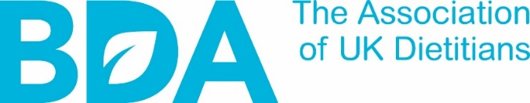

MEMBERSHIP APPLICATION FORM

Return to Practice

Eligibility

As stated by the HCPC Return to Practice criteria you must have been out of the profession for more than 2 years and you must be undertaking a return-to-practice route of:

- 30 days (out of the profession between 2- 5 years) undertaking 15 days of self-directed learning & 15 days of supervised practice or formal study

- Or 60 days (out of the profession for more than 5 years or never registered with the HCPC on qualifying) undertaking 30 days of self-directed learning & 30 days of supervised practice or formal study

- Supervised practice or formal study can either be in a placement setting such as a dietetic department in the NHS or a formal course through a learning institution or a recognised professional body such as the British Dietetic Association

Must be returning to practice via one of these routes:

- A recognised formal course through an institution or professional body

- Undertaking a recognised AHP Return to Practice Course e.g., Coventry University or Birmingham University

- Undertaking paid or unpaid supervised practice as stated in the HCPC RTP criteria as part of the required hours needed to gain registration with the HCPC

Declaration

IMPORTANT: By applying for this category, you are declaring:

- I confirm I am Returning to Practice via one of the routes listed above

- I understand my obligation to inform the BDA of my re-registration to the HCPC, so I can be upgraded to full membership immediately. In this case, the BDA will refund any pre-payment (where owed) for RTP membership paid in advance

Title:
First Name:
Middle Name:
Surname:

Home Address Details
Line 1:
Line 2:
Line 3:
Country:
Postcode:

Contact Information
Email:
Phone:
Email:

Name of Employer or Institution (e.g., Trust Name/Local Authority/University
University:
Course start date:
Course end date:

Employer’s Main Address

University:

Place of Work: (if applicable – e.g. Department or Hospital)

Work Address (if different from employer`s address)

Line 1:
Line 2:
Line 3:
Country:
Postcode:

PREFERRED PAYMENT METHOD | Card |  | Annual Direct Debit |  | Monthly Direct Debit

If choosing to pay by Direct Debit, please also complete the accompanying Direct Debit form

PREFERRED MAILING ADDRESS | HOME |  | WORK

