Relaunching our South West Branch

Introducing Our New Committee Members

After a period of inactivity, we are excited to announce that we will be relaunching our South West branch. We are looking forward to putting plans in place to support members across the region. We are very grateful to the BDA members who have stepped up to volunteer on the committee. Introducing:

Polly Taylor – Chair
“I am delighted to be given the opportunity to reinvigorate life back into the South West Branch of the British Dietetic Association. Our goals are to build links between departments and specialities, both inside and outside of the NHS, to provide more opportunities for networking, strategic development within services and CPD in terms of knowledge and experience.

I have worked for the past 8 years as the Dietetic Lead for Eating Disorders in Somerset, and previously worked in locum roles all around the UK in different specialities, in both general and mental health. I have also spent some time work privately, as an elected staff governor, and for the CQC. I look forward to connecting with all the members of the BDA in South West, please do feel free to contact me with any ideas you would like to voice”.

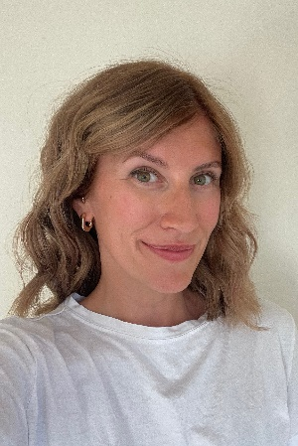
“I am delighted to have been given the opportunity to be part of the committee for the South West branch. The BDA branches are key to connecting dietitians across the region to collaborate and share best practice. I graduated from Coventry University in 2016 and have worked across Diabetes, Renal and Critical Care. I am now the Bristol, North Somerset, and South Gloucestershire (BNSSG) AHP Faculty Programme Manager and I will soon be taking on an accompanying Research Associate post. I am excited to start meeting with dietetic teams to understand how we can best bring dietitians together to support, promote and celebrate excellent dietetic practice happening across the South West.”

Katie Williams – Secretary

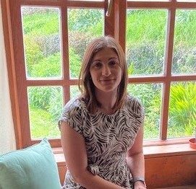
“I graduated from Plymouth University in 2018. I am currently based at North Bristol Trust working with the acute renal team and will soon be working as a team leader to support dietetic students through their practice based learning. I am excited to be joining the BDA South West branch as Treasurer. As part of my role, I will be responsible for the financial management of the branch. I will be working closely with the committee to plan projects and events, as well as the accounts department to ensure all income and expenditure is budgeted for. I’m looking forward to the opportunity to bring dietetic departments across the South West together, so we can learn from each other and share our expertise”.

Becky Slough - Treasurer

Get Involved

Look out for further details of upcoming branch events that you can get involved with. In the meantime, we would love hear from you if you are interested in volunteering alongside Polly, Katie and Becky. We are recruiting for several other committee roles to develop the branch further.

You can find full details of the roles and apply directly on our website: https://www.bda.uk.com/news-campaigns/get-involved/volunteers/volunteering-opportunities.html

To join our volunteer community, please contact volunteers@bda.uk.com for an informal discussion in the first instance.

©2023 The British Dietetic Association
3rd Floor, Interchange Place, 151-165 Edmund Street, Birmingham, B3 2TA
email: info@bda.uk.com

Commercial copying, hiring or lending without the written permission of the BDA is prohibited.

bda.uk.com

